AUTONOMIC CARS
As the owner of a car website Autonomic Cars, Built for Drivers, Engineered for Life. My primary motive is to create a space where car enthusiasts can find valuable information about cars, connect with fellow car enthusiasts, and share their passion for cars that are from Germany. It consists of home page, about us page, contact us page, product and services page and news page.

My website is designed to cater to all types of car enthusiasts and it’s profitable - from casual car lovers to hardcore petrol heads. It features a wide range of content related to cars, including car reviews, news, features, and articles about car enthusiasts and their experiences.

The website is a one-stop-shop for all things automotive. Visitors can find information on the latest car models, industry trends, and top-rated car-related products. The website also features a community forum where car enthusiasts can connect, share their knowledge and expertise, and discuss their favorite cars.

As someone who is passionate about cars, I believe that a website dedicated to cars is essential. There are numerous car companies and dealerships, but a website that focuses solely on cars and the automotive industry provides a unique perspective that is missing from other sources.

My website is aimed at car enthusiasts of all ages, genders, and backgrounds. Whether you are interested in classic cars, sports cars, or muscle cars, my website has something for everyone.

Furthermore, my website serves as a platform to raise awareness about issues related to cars and help people make informed decisions about purchasing or owning a car. The website features articles about fuel efficiency, safety features, and the impact of cars on the environment.

In conclusion, my website is a labor of love, a passion project aimed at creating a community around cars and the automotive industry. With the help of my team and the support of our visitors, I am confident that my website will continue to grow and become an important resource for car enthusiasts everywhere.

D. Websites assets

Graphics: I may create some simple graphics or icons to use on the website to help break up the text and make it more visually appealing.
Buttons: I will create a button for add cart for you to buy the car.
Social media: My website also has social media such as Twitter, Instagram and Facebook.

E. Website Pages and Content:

1. Home Page: The home page will include a banner image of a car and a brief introduction to the website. It will also highlight the main features of Autonomic Cars.

2. About Us: The About Us page will provide more background on Autonomic Cars as a company and explain why their services are important for consumers. It will also highlight the team members who work at Autonomic Cars and their expertise in the field.

3. Product and Services: The Product and Services page is for you to have a look at the car you want to purchase, and we also offer services in this page.

4. How It Works: This page will provide a step-by-step guide on how to use Autonomic Cars. It will also explain how Autonomic Cars obtains its information and ensures its accuracy.

5. Contact Us: The Contact Us page will provide various ways for customers to get in touch with Autonomic Cars, including phone and email support. It will also include a simple form that customers can fill out to request more information or ask a question.

Photos: I plan to source professional photos of cars to use on my website.

Home page
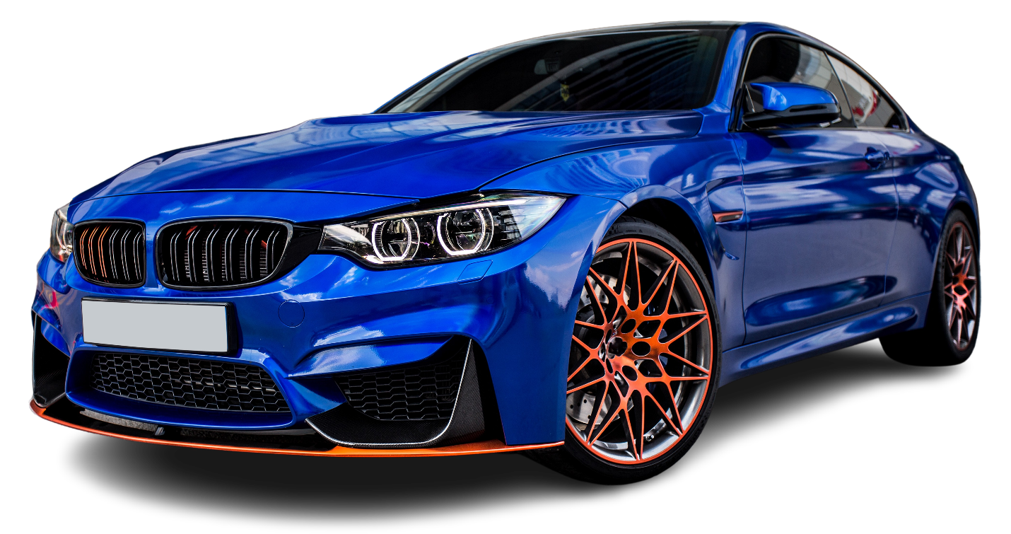

Product and Services

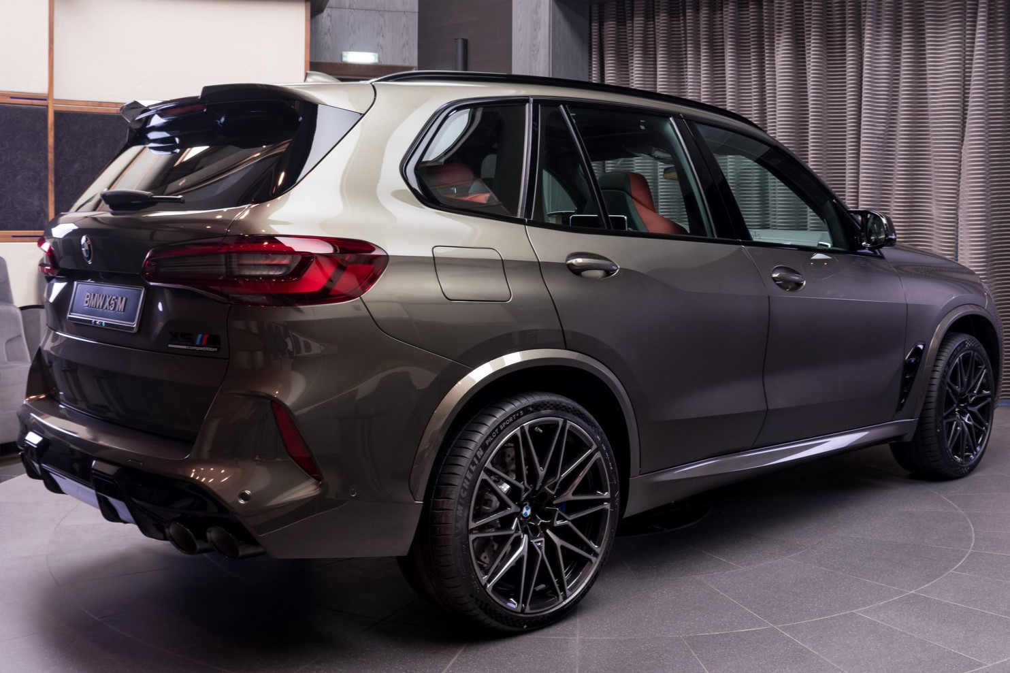

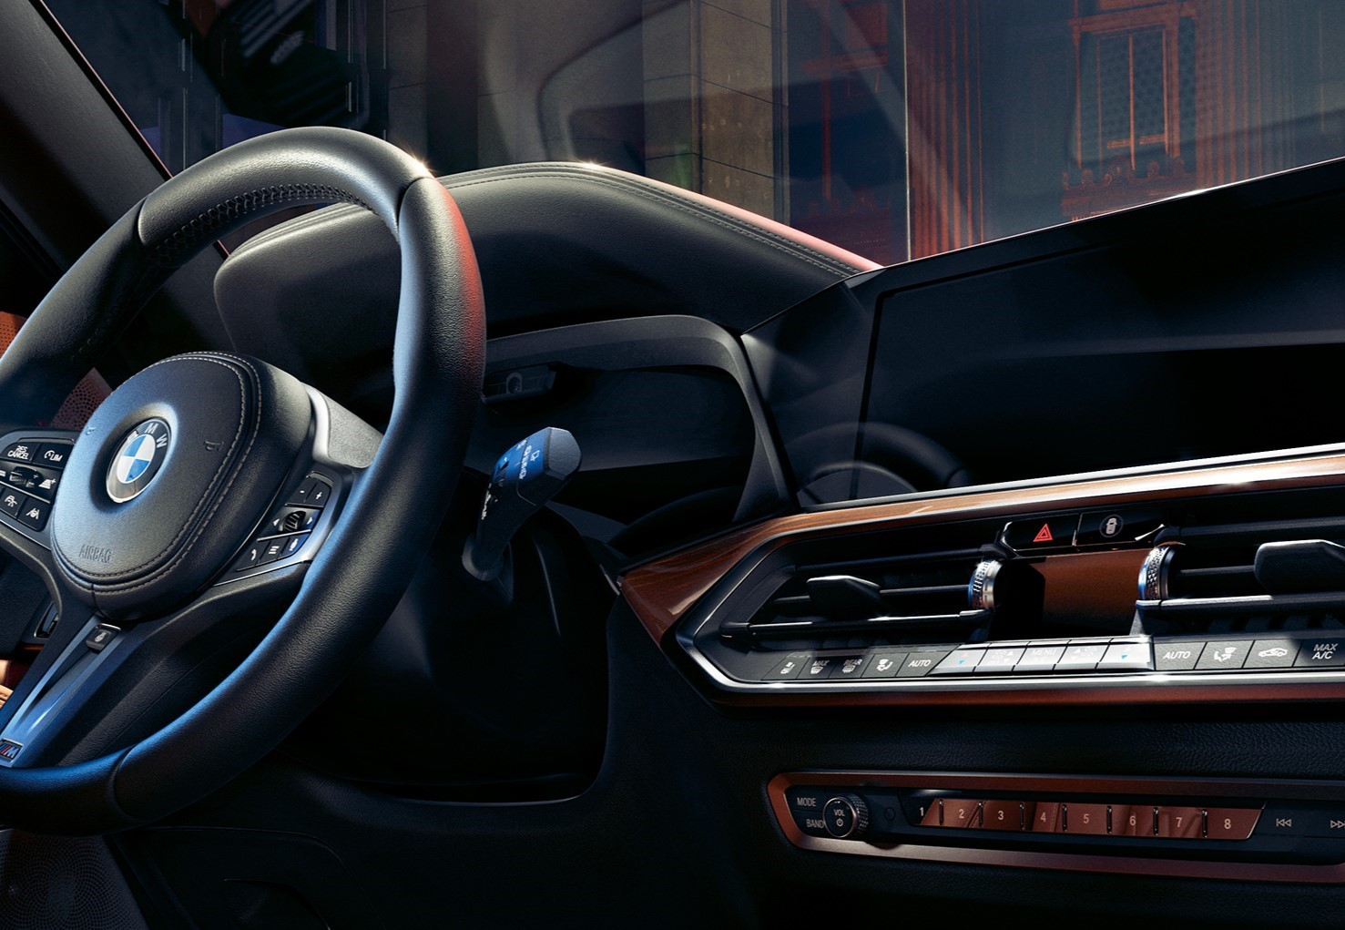
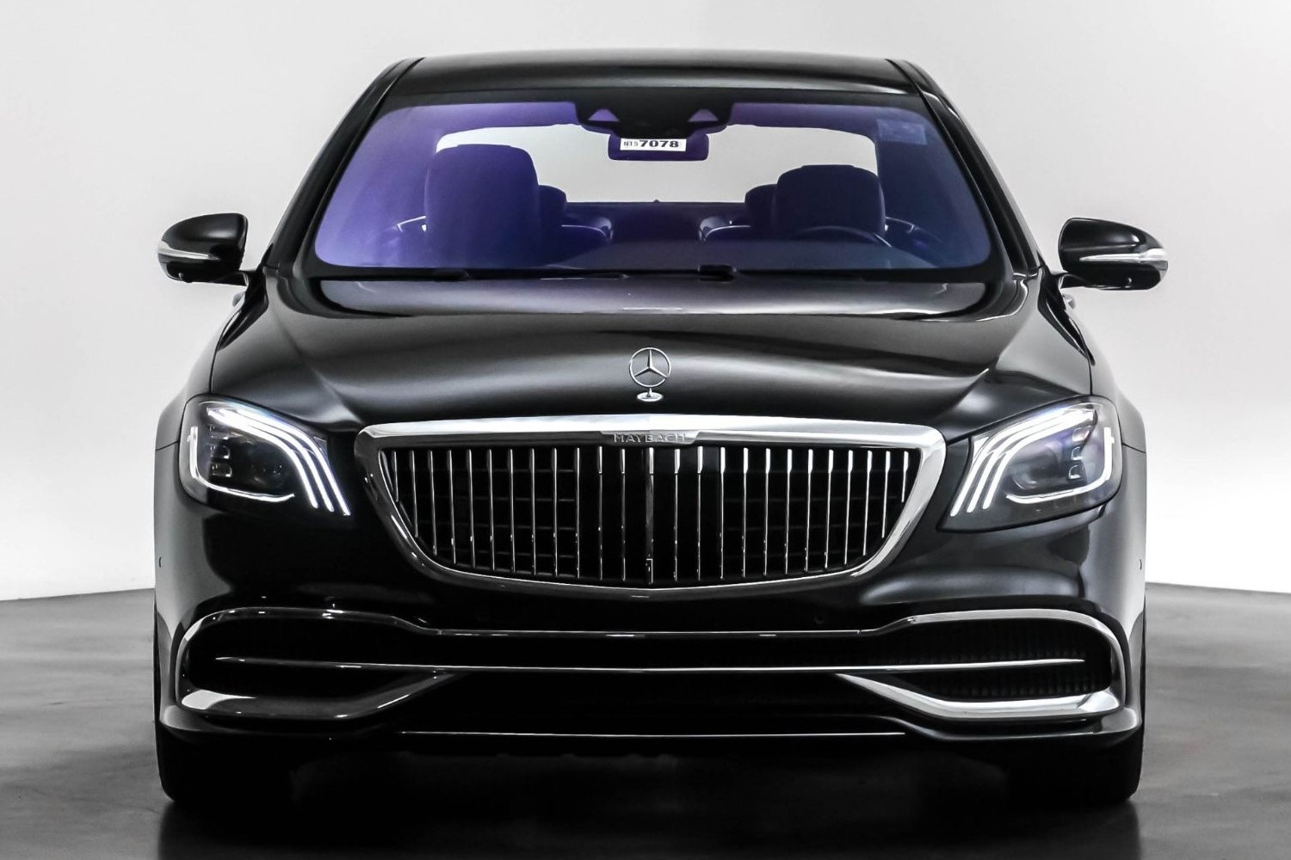

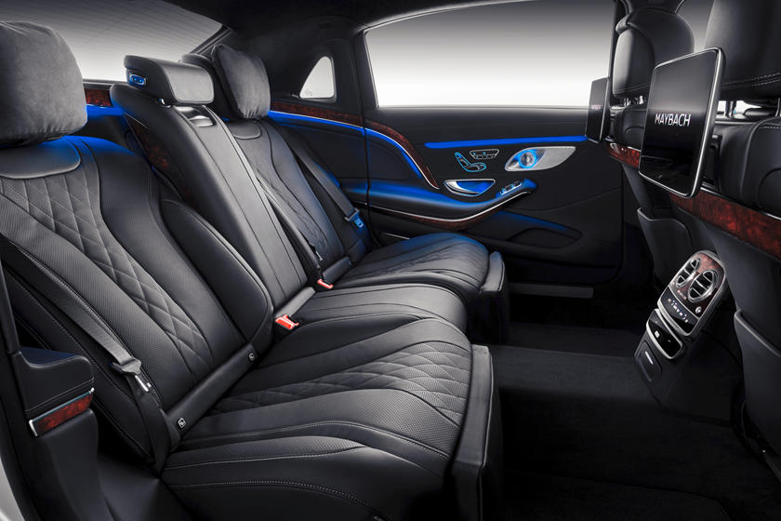

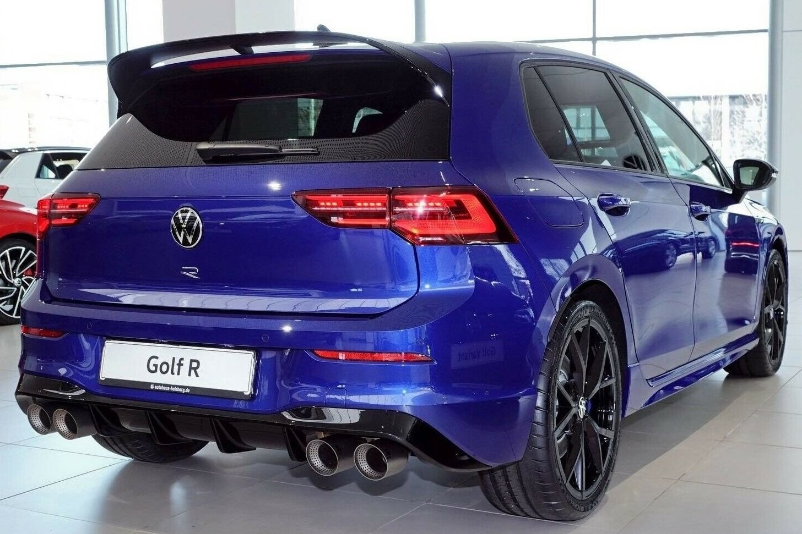
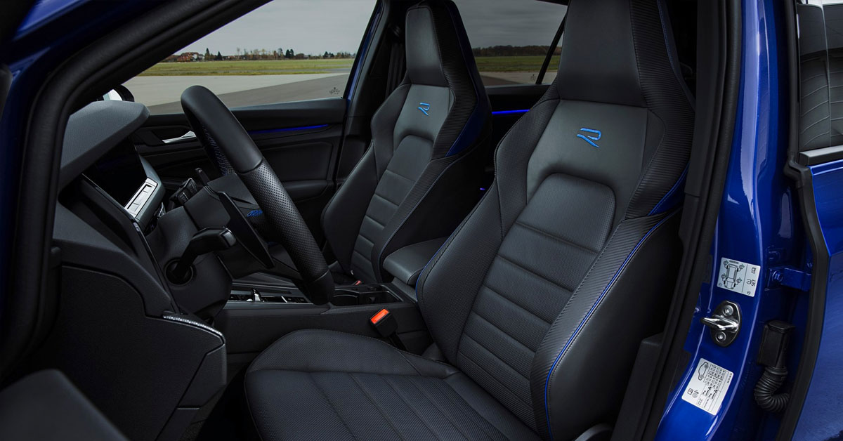

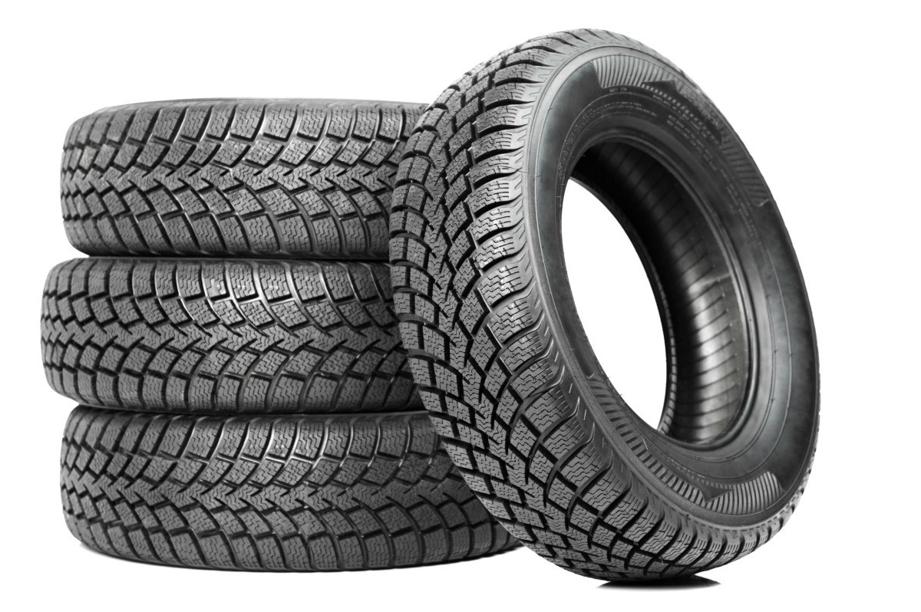
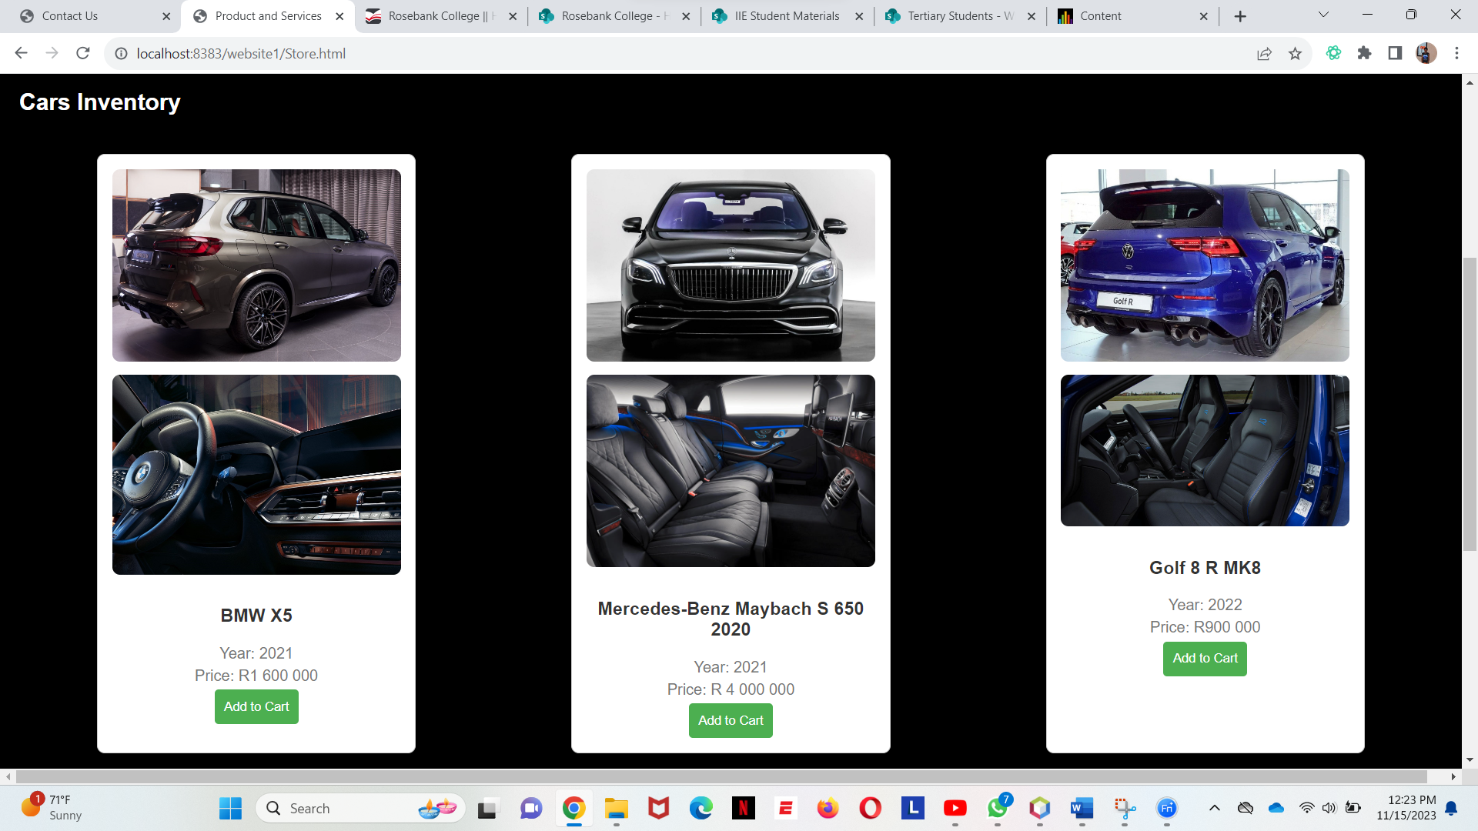

Part 3
Improvements to Part 2

On Autonomic Cars website, the incorporation of JavaScript enhances user interactivity, providing a seamless experience for visitors. The addition of a newsletter and contact feature through Google Forms allows users to stay updated on the latest automotive news and trends. This not only engages the audience but also helps build a community of informed enthusiasts.

The introduction of an "Add to Cart" button on the Product and Services page facilitates a convenient way for users to explore and potentially purchase cars directly through the website. This e-commerce functionality adds a practical dimension to the platform, enhancing its utility for those looking to make automotive-related transactions.

The contact page was improved where you can send an email for the customer to contact the company and keep updated so this enhancement will improve the website and it will be easy for costumers and will improve and be efficient.

Moreover, the implementation of SEO strategies ensures that Autonomic Cars is easily discoverable by individuals searching for car-related content online. This optimization contributes to increased visibility on search engines, attracting a broader audience and solidifying the website's position as a go-to resource for automotive enthusiasts.

In summary, the strategic use of JavaScript, the integration of an e-commerce feature, and the incorporation of SEO techniques collectively enhance Autonomic Cars' website, providing a more engaging, user-friendly, and discoverable platform for car enthusiasts.

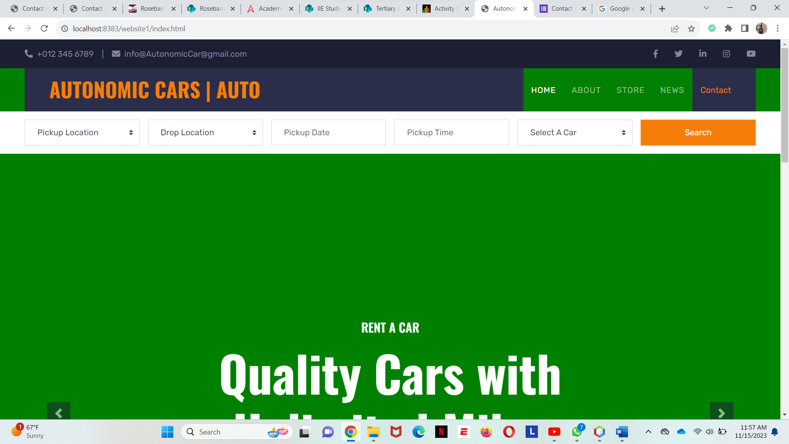

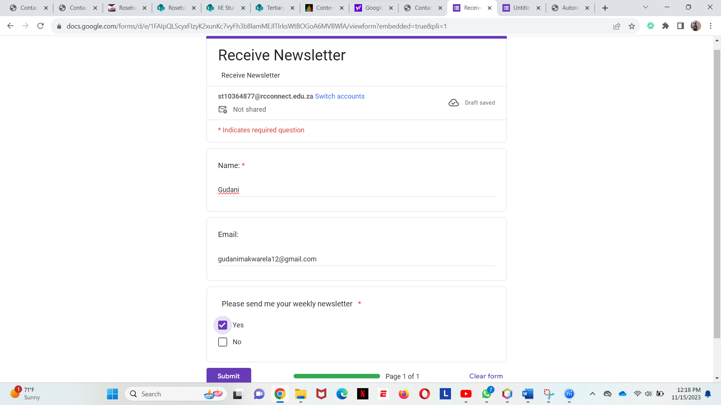

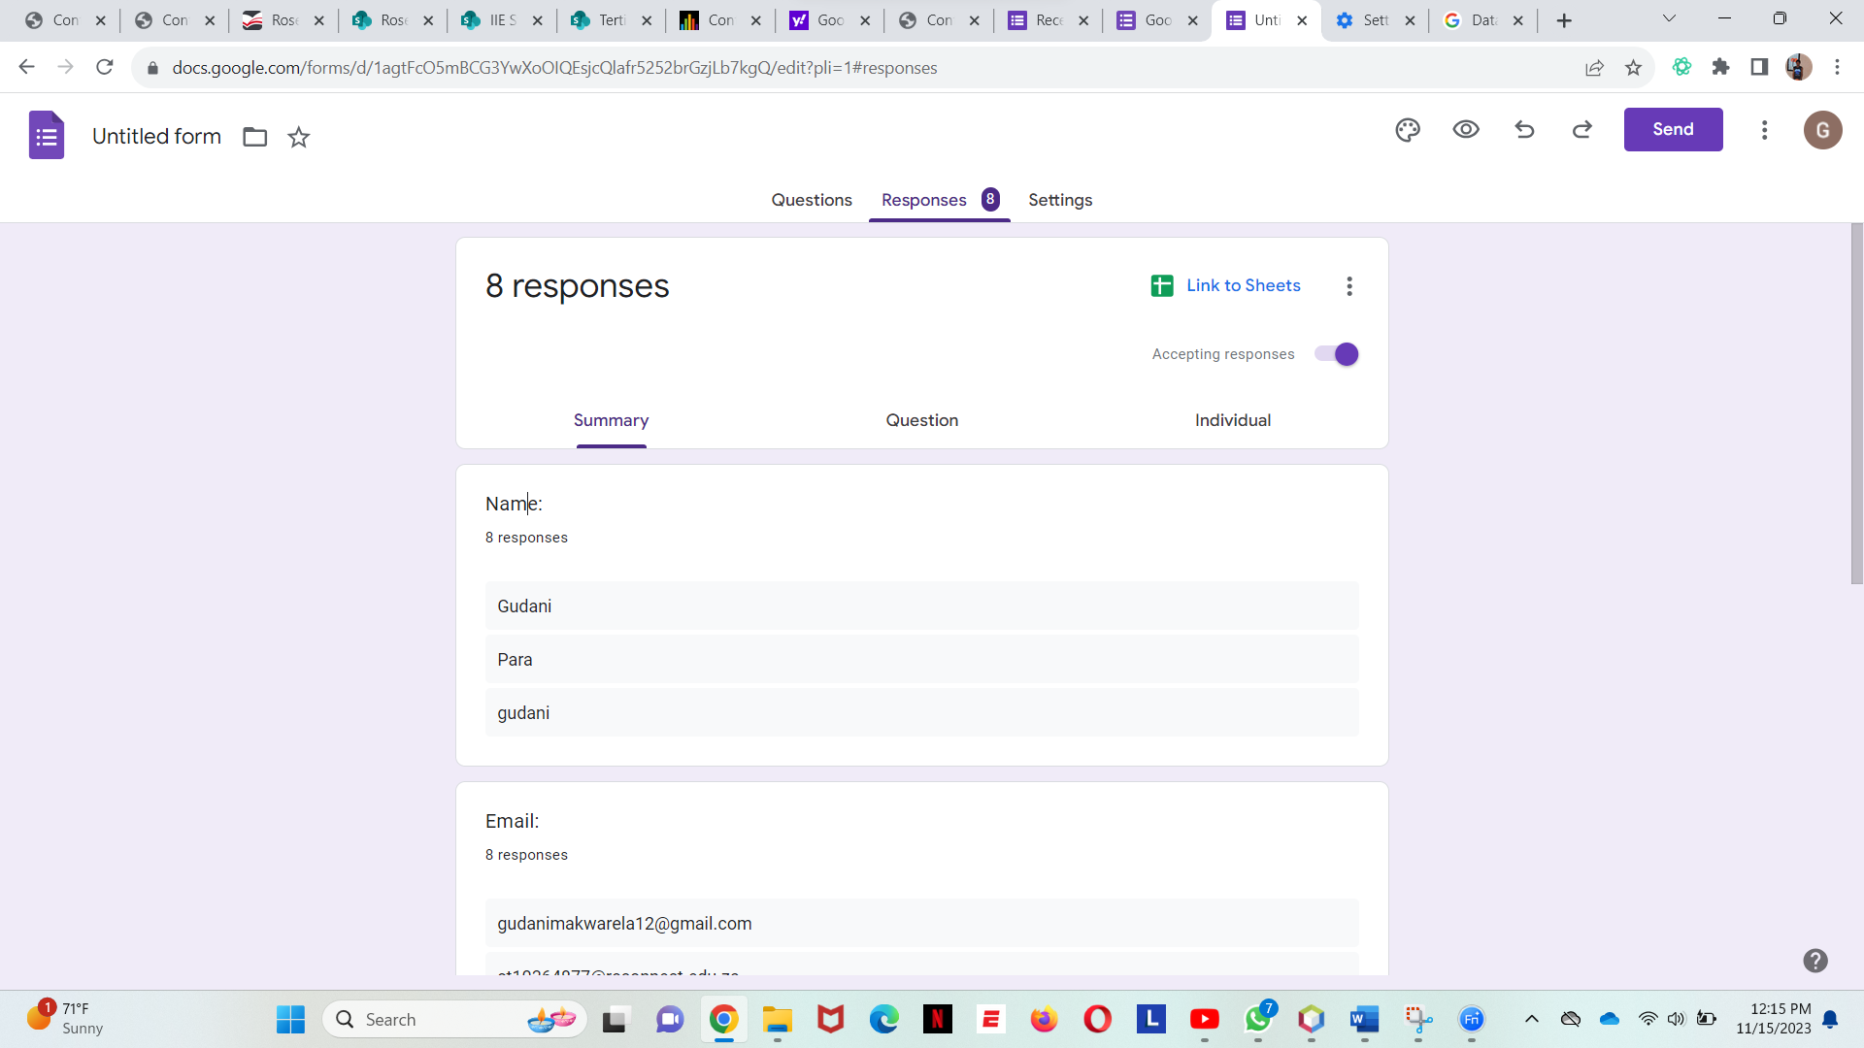

Reference List

Santander Consumer USA. (2021). These are the best used car websites, our research shows. [online] Available at: https://santanderconsumerusa.com/blog/best-used- car-websites [Accessed 15 Nov. 2023].
‌
Consumer Reports. (n.d.). New and Used Car Reviews and Ratings. [online] Available at: https://www.consumerreports.org/cars/.
‌

www.mbusa.com. (n.d.). Mercedes-Original Tires. [online] Available at: https://www.mbusa.com/en/owners/parts/mercedes-original-tires [Accessed 15 Nov. 2023].

accounts.google.com. (n.d.). Google Forms: Sign-in. [online] Available at: https://docs.google.com/forms/u/0/?tgif=d&ec=asw-forms-globalnav-signin [Accessed 15 Nov. 2023].
‌

